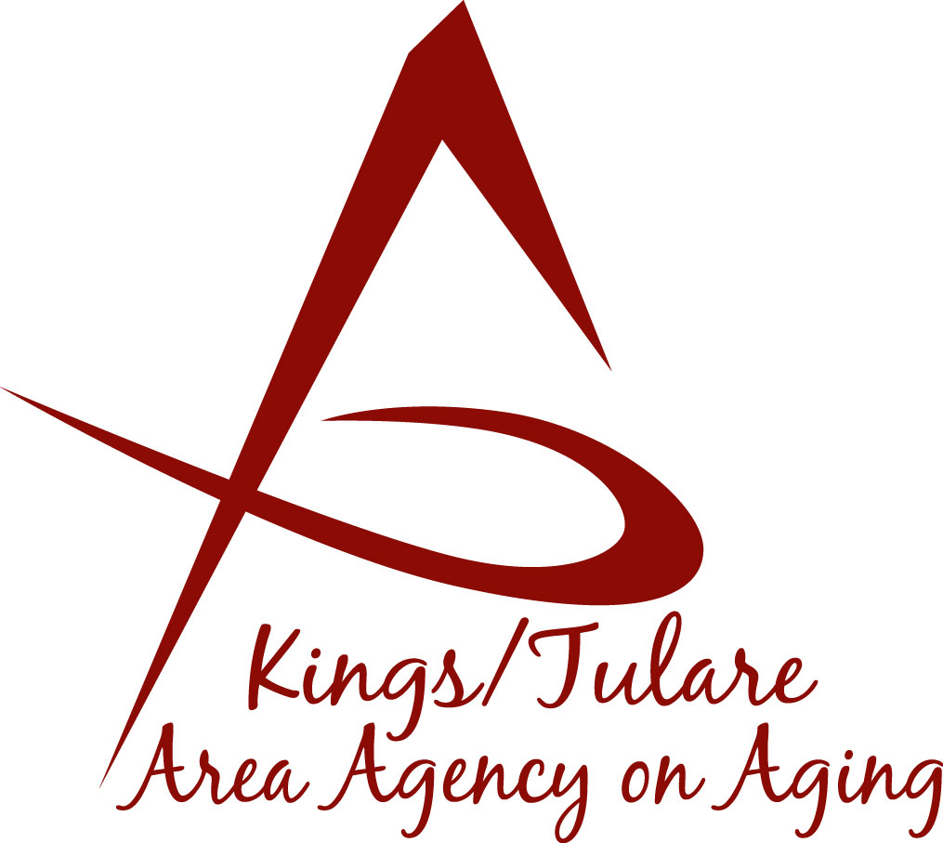ADVISORY COUNCIL AGENDA
(Rescheduled) to Monday, June 24, 2019
Monday, June 17, 2019
10:30 a.m.
Government Plaza Bldg.
5957 S. Mooney Blvd.
RMA Conference Room, 1st Floor
Visalia, CA 93277

- Call to Order Action

- Introductions of Guests and Council Members Information

3. Public Comment 3 minutes
Any person may directly address the Council at this time on any item on the Agenda or any other items of interest to the public that are within the subject matter jurisdiction of the K/TAAA.

4. Approval of Minutes Action
Members present at the previous meeting may comment or correct minutes
from the meeting held on May 13, 2019.

5. Announcements and Correspondence Information

6. Milestone Updates Information
Information regarding current and former members of the Council

7. Triple-A Council of California (TACC) Bobbie Wartson Information

8. 2018-2019 Tulare County Grand Jury Final Report Information
Review of K/T AAA Response

9. Orientation Manual and Council Bylaws Action
Review & approval to acknowledge current documents require no
substantial changes

10. Annual Report Action
Review and approval of the Advisory Council Annual Report or suggested modifications or edits

11. Staff Reports Information

12. Development of the July 2019 Council Agenda Information

13. Additional Member Comments Information

14. Adjourn Action
If there is no further business to attend to, members may adjourn the meeting at this time.
Notice to the Public
In compliance with the Americans with Disabilities Act, if you need special assistance to participate in this meeting, please contact Christine Tidwell at (559) 624-8063.
The disclosable public records related to this agenda are available for public inspection at the reception area of the Tulare County Human Services Government Plaza building, 5957 S. Mooney Blvd. Visalia, CA 93277

